|  |  |  |  |
| --- | --- | --- | --- |
| **Project Name** | Hexacopter 2017 | **Date** | 26/04/17 |
| **Document Name** | Hexacopter Manual | **Version** | 0.1.3 |
| **Date Created** | 04/03/17 |  |  |
| **Last Modified** | 24/03/17 | | |

Contents

Hexacopter Part List 2

Frame 2

Motors 2

Flight Controller 2

Camera 2

Raspberry Pi 2 3

Radio Receiver 3

GPS Module 3

Distance Sensor 3

Batteries 3

Radio Controller 3

Futaba 3

Battery 3

Schematics 4

Web Interface 4

Layout 4

Connection 4

Flight Controls 4

Manual Mode 4

Autonomous Mode 4

Flight Instructions 5

Perform Auto-takeoff 5

Perform Waypoint Navigation 5

Spiral Mode 5

Performing User Tracking 6

Performing Object Tracking 6

Taking Pictures mid-flight 6

Performing Environmental Mapping 6

Joystick Control 6

Camera Calibration 6

Data Review 6

Software 6

Control Flow Diagrams 6

References 7

# Hexacopter Part List

## Frame

DJI Flame Wheel F550 frame made of strong fiber glass PCB material board, is 550 $$ in diagonal wheelbase and 478 ()*$+[7]. This is the main structure holding the complete copter all together. Propellers (6 on-board) are 9.4×5.0 inches and weight 13g.

Net weight is around 2.5 kilograms after all major changes and advancements made, which had a significant impact of the flight time performance. [1]

[Drone laws changed for non-commercial multirotors weighing more than 2 kg, check <https://www.choice.com.au/electronics-and-technology/gadgets/tech-gadgets/articles/drones-and-privacy-rights>]

[Page lied, CAS says recreational is key, <https://www.casa.gov.au/modelaircraft>]

Hexa X configuration frame:

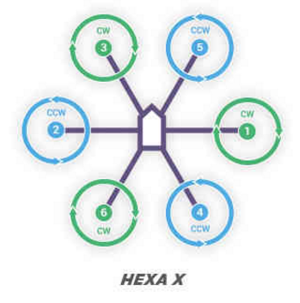

F550 additionally serves as a 11.4V power distribution board (PDB) used by each ESC, as well as:

* Distance sensor voltage regulator? on motor 1
* Pi PATA bus? on motor 5
* Pi board missing power connection?
* Spare JST Connector on back
* Spare solder points at the front

Power input comes from XT60 connection on the back, which passes through a buck converter? Or similar which connects to the flight controller, and power input to that is connected via a UMI-PAC? To the battery.

## Motors

[brand]

AXi 2217/20 840KV

The Motor mounted on board has a stator size of 23×12mm, KV is 960 rpm/V and weight 57g. These motors can be purchased online or retail electronic stores for about $100 AUD. These motors draw a combined current of about 60 Amps while taking off the ground [1]

## ESCs

6x 30A OPTO ESCs

Can take 3S or 4S Voltages (11.4V or 14.8V)

KV:

## Props

DJI branded 1038 Props

8mm hex nuts

[Check Size and pitch]

## Flight Controller

Pixhawk (original)

Running ArduPilot firmware: ASM:Copter for PX4

168MHz

252 MIPS Cortex-M4F

14 PWM outputs

Integrated backup system for in flight recovery and manual override [1]

Pixhawk is based on the PX4, which is made by the same company and is very similar, however it appears to be smaller and resolves limited power issues.

Pixhawk is capable of running Ardupilot firmware, which originally was designed for APM1 and APM2 boards, but this firmware is much more open and configurable.

## GCS

### Mission Planner

Configuration can be performed via the Mission Planner GCS software

There appears to be a similar GCS called APM-Planner that is cross platform

### Ground Control

QGroundControl is promoted via the Pixhawk website, primarily aimed at the PX4, and is cross-platform (presumably because it was programmed with Qt).

**Make sure that Ardupilot firmware is flashed, not PX4 Autopilot**

## Camera

Raspberry Pi Camera Module v1 released in 2013.

|  |  |
| --- | --- |
| Specifications | |
| Size | 25 x 4 x 9mm |
| Weight | 3g |
| Still Resolution | 5 Megapixels |
| Video Modes | 1080p30, 720p60 |
| Fixed Focus |  |
| Focal Length |  |
| Horizontal FOV |  |
| Vertical FOV |  |

[1]

Further details at <https://www.raspberrypi.org/documentation/hardware/camera/README.md>

## Raspberry Pi 2

## Radio Receiver

Futaba R7008SB 8-Channel receiver

## GPS Module

[Model No]

1 GPS attached to frame, 1 raised GPS/Compass

## Distance Sensor

PULSEDLIGHT with 2 servos

|  |  |
| --- | --- |
| Specifications | |
| Size |  |
| Weight |  |
| Still Resolution |  |
| Video Modes |  |
| Fixed Focus |  |
| Focal Length |  |
| Horizontal FOV |  |
| Vertical FOV |  |

[1]

## Wifi Router

TPLINK WR703N

5V 1A

Running OpenWRT

SSID: OpenWrt

Wireless is currently disabled

Gateway IP: 192.168.1.1

## Batteries

Hexacopter uses a single 3000mAh 3S LiPo that is to be attached to the underside of the vehicle.

[Max, Min, Storage charge values]

These batteries can be charged with an available universal chargers universal chargers.

*Note: Make sure to use balanced charging to avoid cell damage as this will prevent individual cells from overcharging and reduce the risk of over discharging when in flight.*

*Note: LiPo manufacturers recommend charging at a rate no higher than IC (that is 3.0A)*

# Radio Controller

## Futaba

Futaba T14SG 14-Channel Radio, installed receiver in the hexacopter is up to 8-channel.

Channel Mapping:

Mode 2

|  |  |  |
| --- | --- | --- |
| **Control** | **Channel** | **Action Mapping** |
| Left Gimbal X | 4 (Right +ve) | Yaw |
| Left Gimbal Y | 3 (Up +ve) | Throttle |
| Right Gimbal X | 1 (Right +ve) | Aileron |
| Right Gimbal Y | 2 (Down +ve) | Elevator |
| SE (Left 3-way switch) | 5 | Flight Mode |
| SF (Left 2-way switch) | 5 | Flight Mode |
| LD | 8 |  |
| RD | 7 |  |

May want to change radio settings such a warning is given until all controls are returned to the default position after turning on.

[version]

[link to manual]

[radio bindings diagram]

[telemetry]

## Battery

The radio transmitter is powered via a 4 cell NiMH pack located at the bottom of the remote.

The radio is chargeable via the black power adapter labelled “hexacopter controller” that should be kept with the radio container.

The battery can be charged directly from the adapter via the small 3 pin connection, or via the radio built in charger by connecting the cylindrical connector on the same charger.

*Note: the radio cannot be powered directly from the charger, therefore it is recommended to always keep the battery charged once it is low.*

# Schematics

[Block diagram of connections and port types]

# Web Interface

[step by step with images]

<https://github.com/jtanx/picopterx/wiki/Using-the-web-interface>

### Layout

[Pictures]

### Connection

1. Connect to the raspberry pi wifi hotspot
2. Navigate to the raspberry pi IP address <http://10.1.1.1>
   1. Via Ethernet, interface is available at <http://10.0.0.10>
   2. If running local machine, available at <http://localhost> or <http://127.0.0.1>
3. Once loaded, the status bar should be green
   1. If not, make sure that the server software (picopterx) is running

# Flight Controls

## Manual Mode

Manual mode configuration allows the operator’s radio to control the flight controller directly.

Altitude hold?

GPS Assisted?

Mode 1 or 2?

Raspberry Pi power and web interface?

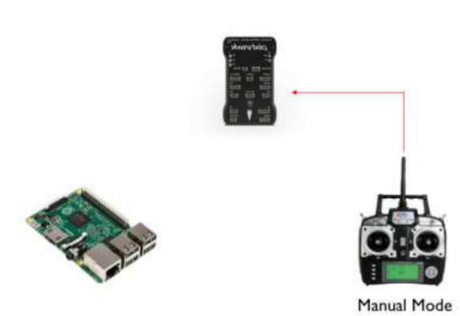

Figure [1]

## Autonomous Mode

Is defined as the operational mode where input to the flight controller comes from the on-board computer. User input in this mode is done entirely via Wifi connection via a web interface hosted by the onboard computer.

[Switch direction?]

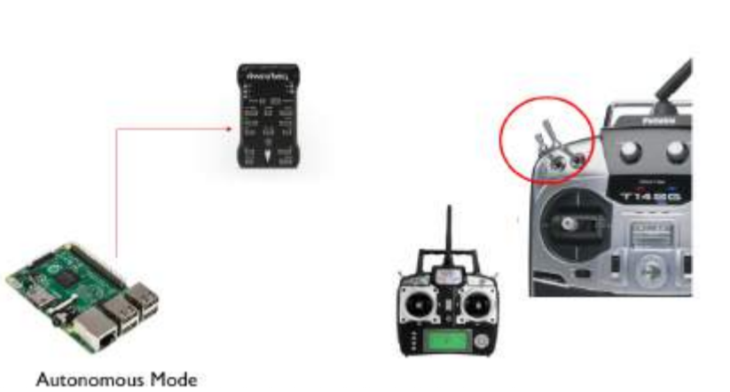

Figure [1]

## Flight Instructions

Flight instructions are available from <https://github.com/jtanx/picopterx/wiki/Using-the-web-interface>

### Perform Auto-takeoff

1. Ensure that the hexacopter is started and that it has a GPS lock. Ensure it is in PosHold mode.
2. From the waypoints tab, click on the dropdown box next to "Begin Flight". Select "Take off". From the popup, specify the height that you wish to take off to and press Begin. The server is now waiting for authorisation to take off.
3. Arm the hexacopter.
4. Switch to GUIDED mode. The hexacopter should now be performing the automated takeoff. After the take-off is complete, ensure that the throttle stick on the controller is in the centre position to ensure that there is some thrust when switching back to manual mode.

### Perform Waypoint Navigation

1. From the waypoint tab, select the pattern that you wish to use.
2. Click on the "Edit" button. The map is now in edit mode.
3. To add waypoints, click on the map. You can drag markers around to reposition them.
4. If you wish to specify specific points at which the markers should be at, use the waypoints editor. This is located below the map.
5. In the waypoint editor, an altitude of 0 means that the altitude will not be changed. If set to any other value, this specifies the **absolute** altitude that the hexacopter will fly to (relative to ground/take-off point).
6. Once the waypoints are entered, press "Edit" again to exit edit mode. Press "Begin Flight" to begin the mission.

### Spiral Mode

Spiral mode actually allows the hexacopter to either fly in a 2D circle, 2D spiral or 3D spiral. A 2D spiral is specified by two control points (waypoints 1 and 2).

The first control point is always the centre of the spiral/circle.

The second control point either specifies the radius of the circle or the starting point of the spiral.

If provided with a third control point, a spiral pattern is created. The third control point specifies the end point of the spiral. At this point, it is still a 2D spiral.

To make it a 3D spiral, you must specify the start and end altitudes using the waypoint editor. The start and end altitudes must be specified on the second and third control points. These values are both relative to the ground/launch point.

If only one altitude is provided, it will remain a 2D spiral.

### Performing User Tracking

### Performing Object Tracking

### Taking Pictures mid-flight

### Performing Environmental Mapping

### Joystick Control

### Camera Calibration

### Data Review

# Software

## Architecture

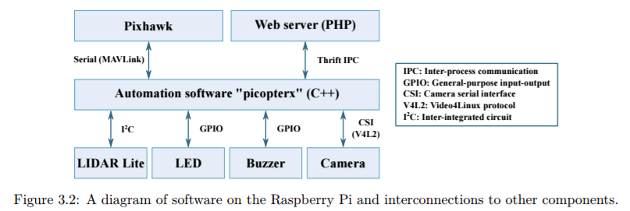

### WWW

Apache PHP install uses this folder for static routes.

### System

Contains files that need to be copied to the root filesystem

### code/src/apps

Standalone programs, probably for testing only.

### code/src/base

picopter_base library, classes for interacting directly with devices,

### code/src/modules

picopter_modules library, classes for Pi navigation

### code/src/server

Apache thrift IPC server, depends on picopter_base, picopter_modules, thrift generated cpp

Simply named picopter

## Third Party

### OMXCV

GPU assisted JPEG encoder for OpenCV and Raspberry Pi

## Control Flow Diagrams

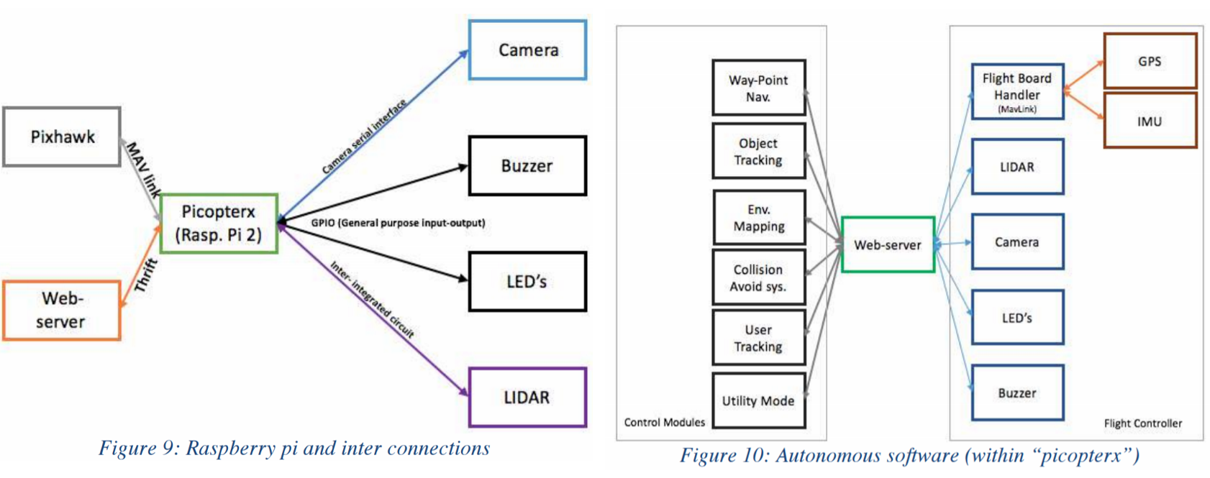

Figure [1]

Figure [3]

# Troubleshooting

### Not Arming

Make sure battery is above the Failsafe set in Mission Planner

### Mission Planner not connecting

Make sure ardupilot firmware is uploaded

Worse case, install PX4, then Arducopter

### ArduCopter Setup

Make sure you perform setup steps in order

Accelerometer part 1 THEN part 2

* Part 1 will fail if part 2 is done before it
* Make sure to lean the arm on a stable surface to avoid oscilation

Radio thresholds

ESC calibration

Make sure failsafe battery voltage is LESS than 11.6, defaults often set to ~14.2

Compass calibration does not need to be done in any particular order

* Move copter in all direction in axis, with default learning

# References

|  |  |
| --- | --- |
| [1] | M. Mohanty, “Environmental Mapping in 2D/3D,” 2015. [Online]. Available: http://robotics.ee.uwa.edu.au/theses/2015-Hexacopter3D-Mohanty.pdf. |
| [2] | J. Tan, “picopterx,” [Online]. Available: https://github.com/jtanx/picopterx/wiki/. |
| [3] | J. Tan, “Real time point of interest identification,” 26 October 2015. [Online]. Available: http://robotics.ee.uwa.edu.au/theses/2015-HexacopterVision-Tan.pdf. |